Sample Paper- 2016
Subject: MATHEMATICS
Class 12th

MM:100 TIME: 3HRS. 0

Note : Section A comprises of 6 questions of 1 mark each, section B comprises of 13 questions of 4 marks each and section C comprises of 7 questions of 6 marks each.

SECTION-‘A’

Q1. Find the general solution of the differential equation .
Q2. In the interval , find the value of x for which the matrix is singular matrix.
Q3. Find the angle between the lines .
Q4. Find the value of so that the vectors are perpendicular to each other.
Q5. Find the projection of the vector
Q6. Write the integrating factor of the differential equation
SECTION-‘B’

Q7. If
Q8. Determine the value of the constant k so that the function
is continuous at
Q9. Find the equation of the plane passing through the line of intersection of the planes and parallel to the line
Q10. Evaluate .
OR
Evaluate as limit of a sum.
Q11. If find a and b.
Q12. If , prove that .

Q13. Use matrix multiplication to divide Rs. 30000 in two parts such that the total annual interest at 9% on the first part and 11% on the second part amounts Rs. 3060.

Q14. Prove that .
Q15. Evaluate
OR
Evaluate
Q16. Evaluate
Q17. If , then prove that
.
OR
Using differentiation find the approximate value of
Q18. If prove that
Q19. A man takes a step forward with probability 0.4 and backwards with probability 0.6. Find the probability that at the end of eleven steps he is just one step away from the starting point.
OR
Two cards are drawn successively with replacement from a well shuffled deck of 52 cards. Find the mean and standard deviation of the number of aces.

SECTION-‘C’

Q20. Solve the following initial value problem
OR
Solve the differential equation
Q21. Show that the volume of the greatest cylinder which can be inscribed in a cone of height h and semi-vertical angle
OR
If curves intersects orthogonally, then prove that
Q22. In a group of 400 people, 160 are smokers & non-vegetarian, 100 are smokers & vegetarian and the remaining are non-smokers & vegetarian. The probabilities of getting a special chest disease are 35%, 20% and 10% respectively. A person is chosen from the group at random and is found to be suffering from the disease. What is the probability that the selected person is a smoker & non-vegetarian? What value is reflected in this question?
Q23. Show that the relation R in the set given by is divisible by 2} is an equivalence relation. Write all the equivalence classes of R.
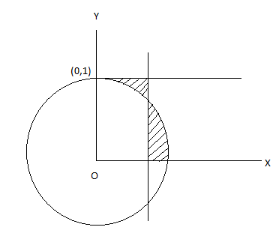
Q24. Find the distance of the point (3,4,5) from the plane measured parallel to the line .
Q25. Consider the first quadrant of the circle What value of h will minimize the sum of the area of shaded region.

Q26. A manufacturer produces two types of steel trunks. He has two machines A and B. The first type of trunk requires 3 hours on machine A and 3 hours on machine B. The second type of trunk requires 3 hour on machine A and 2 hours on machine B. Machines A and B run daily for 18 hours and 15 hours respectively. There is a profit of Rs. 30 on the first type of truck and Rs. 25 on the second type of the trunk. How many trucks of each type should be produced and sold to make maximum profit?

(Agt)

Answers:
Q1. Q2. Q3.
Q4. Q5. Q6.
Q7. 22 Q8. – 1 Q9.
Q10. OR
Q11.

Q13. 12000 & 18000
Q15. OR
Q16.

Q17. OR 45.46
Q19. OR
Q20. OR
Q22.

Q23. {1,3,5} & {2,4}

Q24. 6
Q25.
Q26. 3 trunk of each type & maximum profit of Rs. 165.

MATHS by Er. AJEET Sir
B-36, VAISHALI NAGAR B-BLOCK, JAIPUR : 98292-34167

